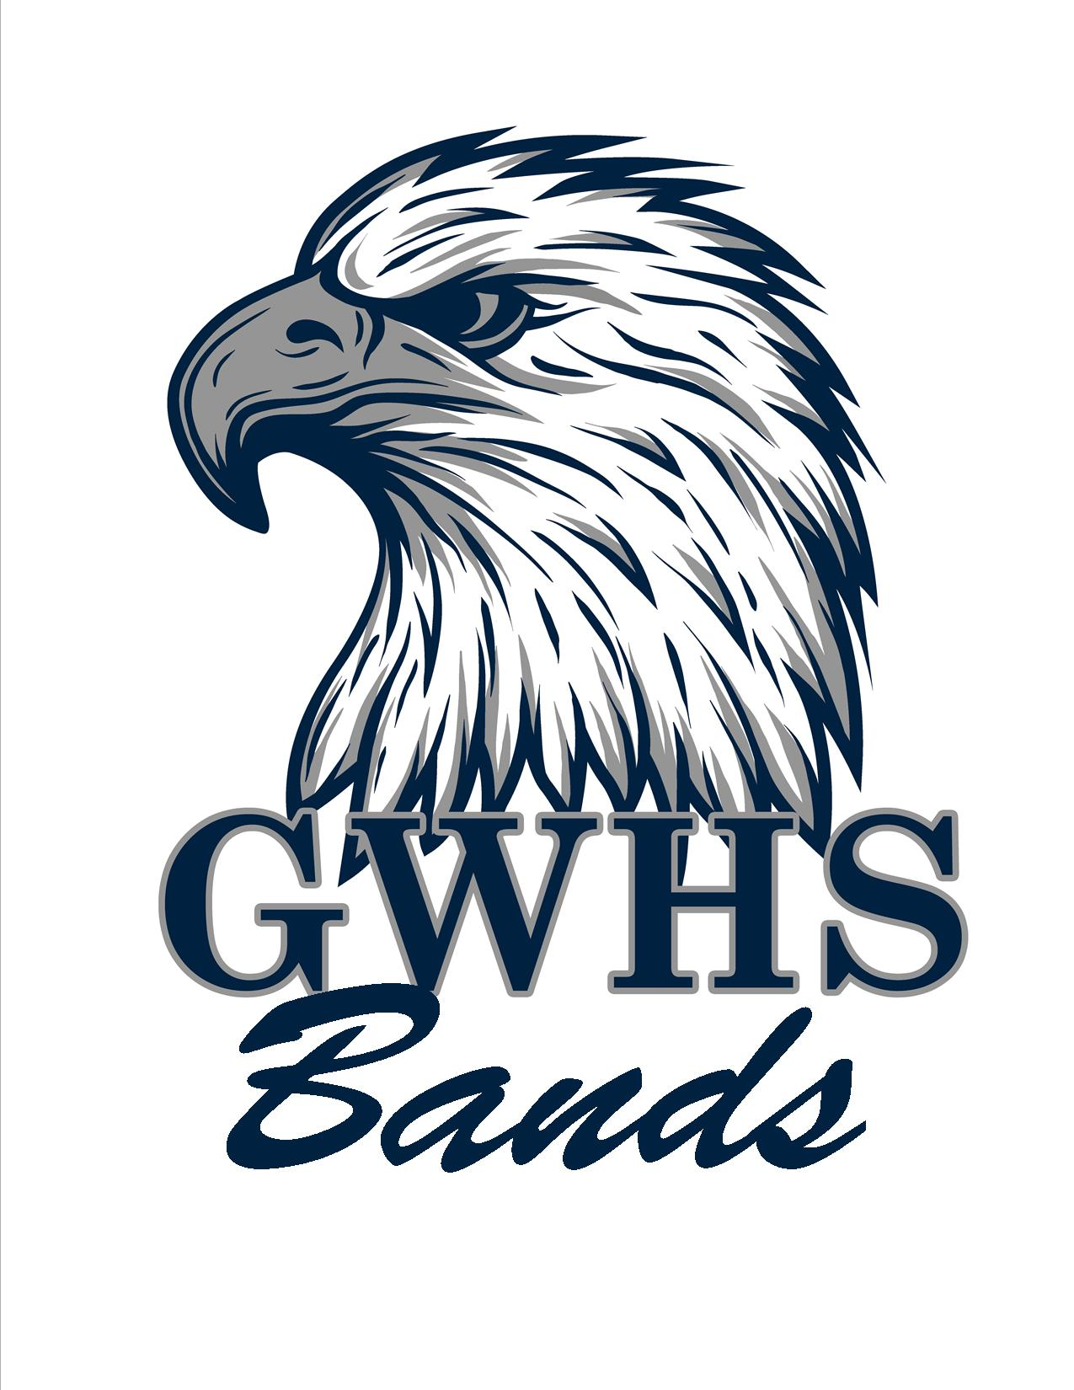

George Washington High School Bands
701 Broad Street
Danville, VA 24541
(434) 799-6410

Greetings,

The Bands at GWHS are raising money for our program. We are seeking donations of at least $5.00 to become Friends of the Band. Every dollar that is donated, will go to feeding our members, cleaning uniforms, providing transportation, and funding our band camps and rehearsals. Names of those who are Friends of the Band will be printed in the River City Classic Program, (our marching contest on September 25, 2021) and our concert programs this school year. You may also make donations at gwband.org. Be sure to mention the student you are supporting in the subject line. THANK YOU in advance for your donation and support of the Bands at GWHS!

Cody Kesling - Director of Bands

** Donations due September 17, 2021**
Name how it should be printed (Print Clearly) Donation Amount

1________________________________________ $_____________
2________________________________________ $_____________
3________________________________________ $_____________
4________________________________________ $_____________
5________________________________________ $_____________
6________________________________________ $_____________
7________________________________________ $_____________
8________________________________________ $_____________ 9________________________________________ $_____________
10_______________________________________ $_____________
11_______________________________________ $_____________
12_______________________________________ $_____________
13_______________________________________ $_____________
14_______________________________________ $_____________
15_______________________________________ $_____________

