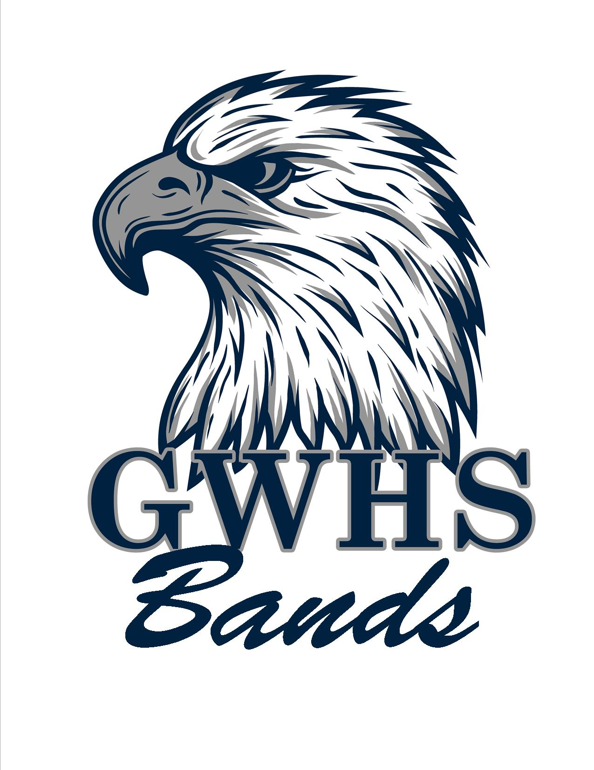
GW Band Parent Organization, Inc.
P.O. Box 10003
Danville, VA 24543

Dear _________________________,

The award winning George Washington High School Marching Eagles are gearing up for a fun filled season full of music, performing, and travel! This year, the Marching Eagles will be performing at football games, local competitions and parades! We are excited to get back to performing.

We need your help! Our fundraisers alone will not be enough to finance all our projects, and needs. We are asking that you please help by sponsoring a member and sending a donation of any size to our program. All donations will be directly applied to a student and their band fee. Please fill out the form below and mail with your donation to P.O. Box 10003, Danville, VA 24543. We are asking that all donations are received by August 19, 2021. All donations are tax deductible.

Thank you in advance for your supporting the GWHS Band Program!

Cody Kesling
Director of Bands

______________________________________________________________________

Name:______________________________________________________________

Address:____________________________

____________________________

Donation Amount: $____________________

Benefiting Student:_____________________

